<EMPTY> …………………..CALENDAR………………

E-MAIL:schools.masaka@yahoo.com

PHONE: 0713322737,0716750710,0762085152

PO.BOX 17002 KIPUNGUNI “B"

DAR ES SALAAM , TANZANIA

EAST. AFRICA.

E

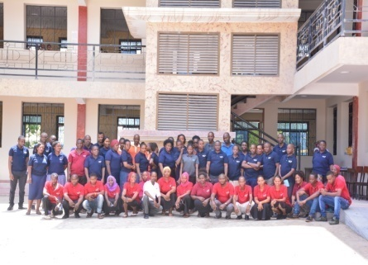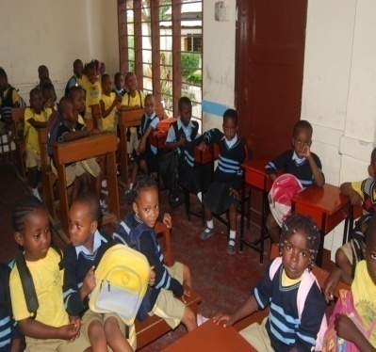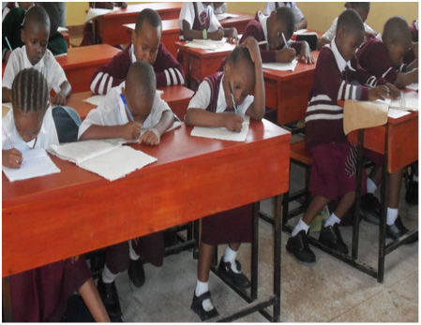 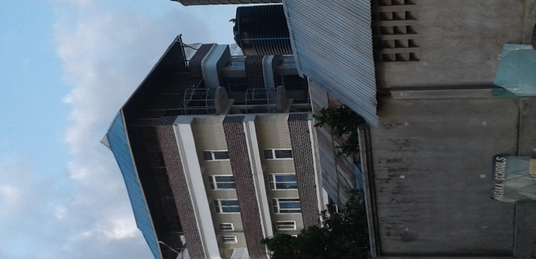 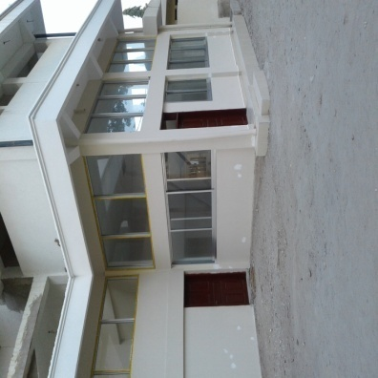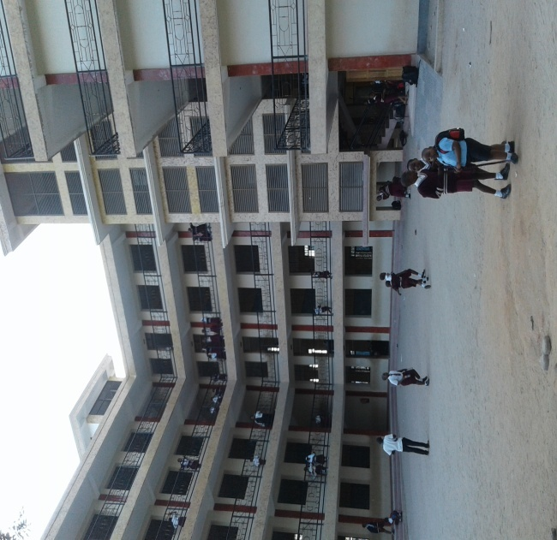

QUALITY EDUCATION IS THE ULTIMATE INVESTMENT

2021

